Lancashire Road Club Hill Climb Ramsbottom Rake L812
Sunday 16th October 2022
Promoted for and on behalf of Cycling Time Trials under its Rules and Regulations’
Prize Winners
Overall
1st Kieran Wynne-Cattanach Team Lifting Gear Products 2:26.0 £100.00
Frank Douglas Cup, winner’s jersey, framed print.

2nd Tom Bell High North Performance 2:27.1 £50.00
3rd Jude Taylor Team PB Performance 2:32.7 £25.00

Female
1st Rebecca Richardson Team Brother UK 3:16.8 £100.00
winner’s jersey, framed print

2nd Bronwen Jenkinson Clwb Beicio Egni/Energy Cycling Club 3:32.5 £50.00
3rd Alice Larkin Glossop Kinder Velo Cycling Club 4:00.6 £25.00

Vet
1st Nicholas Latimer Team Lifting Gear Products 2:36.6 £30.00
winner’s jersey, framed print

2nd Paul Roby Lancashire Road Club 2:42.9 £20.00
3rd Colin Atkinson Muckle Cycle Club 2:50.7 £10.00

Juvenile
1st Jacob Bradbury Manchester Wheelers 3:12.0 £20.00
winner's jersey

2nd Charlie Brennan Sportcity Velo 3:18.9 £10.00

Junior
1st Maxwell Hereward 360cycling 2:44.8 £20.00
2nd Patrick Casey Team Lifting Gear Products 2:49.9 £10.00

Team
1st Team Lifting Gear Products 7:52.5 £30.00
Kieran Wynne-Cattanach
Nicholas Latimer
Patrick Casey

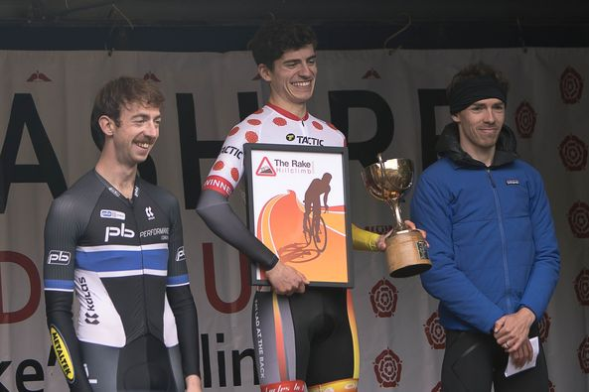
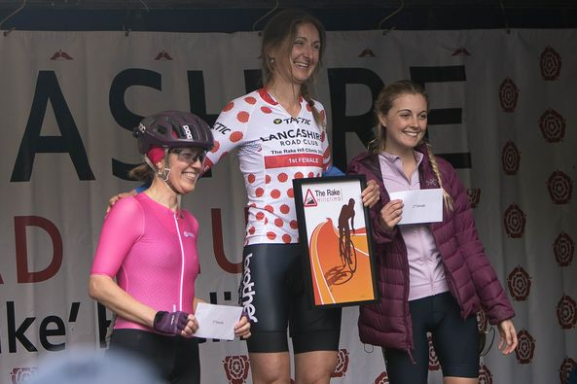

Timekeeper Start: Rick Winstanley
Timekeeper Finish: Roger Winstanley
Recorder: Linda Winstanley

Thanks to all those who helped.

Steve Rowland signing on, Dave price pushing off, Chris Blackmore PA, Gordon Corbett relaying times, Rob Bagot presentation.
All the marshal’s especially those from Bury Clarion.
Special thanks to Glenn Bowyer, race secretary without Glenn’s help it would not be possible to host this event.

